Auto Navigation Landing Page

Description
This extensions will automatically associate a item (defined as a landing page in a configuration file) to the Navon or NavTree residing in the folder it was created in. If the Navon or NavTree already has a Landing Page, then no action is taken.

Prerequisite
Ant needs to be installed on the server to install the extensions

Steps
- Shutdown the server
- Unzip the PSONavAutoLandingPage file into the Rhythmyx directory
- Run installExtensions.bat
- Start the server
- Log into the Workbench
- Switch to the System Design perspective
- Under Relationship Types -> System
- Open the FolderContent Relationship
- Using the tabs on the bottom, switch to Effects

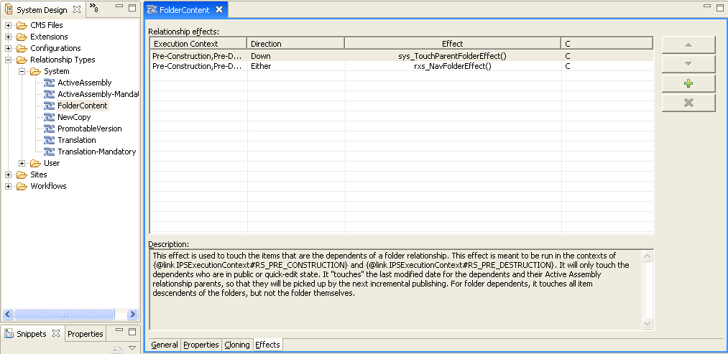

- Replace the rxs_NavFolderEffect() with the new PSONavFolderEffect() leaving the other parameters the same
- Modify the file: rxconfig/Server/landingPageCombinations.xml config to specify the Content Type IDs and Template Names desired as landing pages
- Restart the server
Usage
- Log into the Content Explorer
- Create a new folder (if there is no Navon, create a Navon or a NavTree)
- Create a new item of the allowed Landing Page Type (according to the config file) in the folder
- View the content for the Navon or NavTree, the Nav Landing Page slot has the newly created item in the slot
Tests
1)
  - Create a new item that is not in the allowable Landing Page Types (from the config) in the folder with the Navon
  - The item is created but not associated to the Nav Landing Page slot

  - Create a Landing Page item, confirm that it is associated. Create another Landing Page item
  - The first item is associated to the Navon, the second is just added to the folder

  - Create a Navon or NavTree
  - The item is created successfully

  - Create a NavTree with propagation checked
  - The NavTree is created and the Navons are created in the folders below

